PREDICTING HOUSING PRICES USING MACHINE LEARNING TECHNIQUES
Koh Hui Lyn
School of Computing, Year 2
Singapore Polytechnic

Abstract—With technology constantly improving, the implementation of machine learning in our daily lives will become more and more common. Applying algorithms can help solve many problems by analysing the features or different variables a problem has. This can help save a lot of time as it does not have to be manually done. This paper aims to showcase how I applied machine learning techniques to predict prices of houses in King County in Washington, USA. The dataset I used contained house sale prices for King County, which includes Seattle. It includes homes sold between May 2014 and May 2015. It also has many different types of information that may or may not contribute to its sale price. Some examples of features are: Date, number of bedrooms and toilets, square foot of areas in the house, view scores, condition scores, grade of the house, year built of the house, and many more. These features were then transformed and scaled, before getting fitted into various models for training. This paper aims to find key correlations between the features and the value to be predicted – price.
Keywords—machine learning, algorithm, correlations, dataset.

IIntroduction
It is hard to accurately pinpoint the reasons for prices of houses. This is because there are many factors to determine how much the house is worth. For example, the location of the house – the area it is in, the view of the house, the floor an apartment is on, the design of the house, and many more. These factors all contribute – big or small – to the price of a house. For different areas, the amount in which each factor would impact the price will vary.

Features of the dataset
In the dataset, many features were given. These are the explanation for each feature.

id - Unique ID for each home sold
date - Date of the home sale
price - Price of each home sold
bedrooms - Number of bedrooms
bathrooms - Number of bathrooms, where .5 accounts for a room with a toilet but no shower
sqft_living - Square footage of the apartments interior living space
sqft_lot - Square footage of the land space
floors - Number of floors
waterfront - A dummy variable for whether the apartment was overlooking the waterfront or not
view - An index from 0 to 4 of how good the view of the property was
condition - An index from 1 to 5 on the condition of the apartment,
grade - An index from 1 to 13, where 1-3 falls short of building construction and design, 7 has an average level of construction and design, and 11-13 have a high quality level of construction and design.
sqft_above - The square footage of the interior housing space that is above ground level
sqft_basement - The square footage of the interior housing space that is below ground level
yr_built - The year the house was initially built
yr_renovated - The year of the house’s last renovation
zip code - What zip code area the house is in
lat - Latitude
long - Longitude
sqft_living15 - The square footage of interior housing living space for the nearest 15 neighbours
sqft_lot15 - The square footage of the land lots of the nearest 15 neighbours
Machine Learning
Machine learning is widely used to predict and analyse in many fields. Some the applications of machine learning are to predict prices of various assets or training and learning to recognise various features, in order to come to a accurate conclusion. From predicting stock prices to image recognition, Machine learning can be applied many different scenarios. Algorithms will train and learn based on the given dataset to find patterns, or similarities from the data to try and predict the output variable. Machine Learning can be split into two categories, Supervised Learning and Unsupervised Learning.
- Supervised Learning is where the algorithm receives labelled data. It contains both the inputs and the desired outputs. These labelled data is also called the “train set”. The learning algorithm tries to learn from the given inputs, attempts to establish an relationship and predicts an output. This helps us predict for unforeseen data, as the model would have learnt from its past data. Supervised Learning would allow us to produce a data output from the previous experience, helps us to optimize performance criteria using experience, and also helps us to solve various types of real-world computation problems.
- Unsupervised Learning is where the algorithm works by itself to discover information. It mainly works with unlabelled data. It allows us to perform more complex processing tasks compared to supervised learning. However, unsupervised learning can be more unpredictable compared with other natural learning deep learning and reinforcement learning methods. A reason to use Supervised learning is that finds all kind of unknown patterns in data. It would also help to find features which can be useful for categorization. Unsupervised learning takes place in real time. Compared to Supervised Learning, unsupervised learning is more complicated.

Rrelated works

Using Machine Learning to predict Airbnb rental prices
Airbnb is an internet marketplace for short-term home and apartment rentals. It allows users to rent out their home for a set duration of time, or rent out their spare room to travellers. One challenge that Airbnb hosts face is determining the optimal nightly rent price. In many areas, would-be renters are presented with a good selection of listings and can filter by criteria like price, number of bedrooms, room type, and more. In Airbnb, the amount a host can charge on a nightly basis is closely linked to the dynamics of the marketplace. Thus, machine learning can be used to try and help these hosts predict how much they should rent out their apartments for. For this, K-Nearest Neighbour was used, where several uni-variate K-Nearest Neighbour models was trained. A multi variate one was made after using the RMSE of the univariate models to calculate the errors and improve them. With this they were able to make a suitable Model to predict Airbnb rental prices. [I]

Using Machine Learning to predict stock prices
Predicting how the stock market will perform is one of the most difficult things to do as there are so many factors involved in the prediction. From physical factors, to psychological, to rational and irrational behavior of the market, there are many assets that would combine to make share prices volatile and very difficult to predict with a high degree of accuracy. So this begs the question – Are we able to predict stock prices using machine learning? To test this, many models were applied. For example, models such as Linear Regression, K-Nearest Neighbours, Auto ARIMA, Prophet and Long Short Term Memory (LSTM) were applied. The predictions from these models were accurate to varying degrees, but they were certainly not enough to identify accurately whether the stock prices will really increase or decrease. Stock prices are affected by the news about the company and other factors like demonetization or merger/demerger of the companies. There are certain intangible factors as well which can often be impossible to predict beforehand. Thus it makes it very hard to predict stock prices with 100% accuracy. [II]

Ddataset/methodology/experiment

Data Preprocessing – Making columns more useful
The dataset of House Prices in King County contained an ID column that I felt was unnecessary for my model, so I removed it. I also removed columns that were correlated to each other, like sqft_living, sqft_above, sqft_basement, as they were correlated to sqft_lot, and sqft_living15 as it was correlated to sqft_lot15. I converted the “Date” column into the datetime datatype, and used Date together with yr_built to create a new column which I called “Age” to represent the Age of the house. Using the yr_renovated column, I created a column “Renovated” which tells us whether the house has been renovated before. After this, I dropped the columns that I used.

Data preprocessing – Removing strange values
I plotted a boxplot of bedrooms, which gave me this.
Fig 1: Boxplot of number of bedrooms 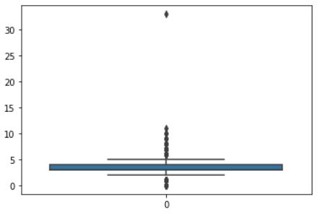
I found that there were extremely odd values of 33 and 0. So I only kept in reasonable values of number of bedrooms. I did the same for Bathrooms as well. The floor feature looked alright, so I did not do anything to it.

Data Processing – Looking for relationships
Next, I wanted to find whether there were any relationships between some of the features and price. So I plotted a few boxplots of features against price. The strongest relationships were Grade and Bathrooms, as seen from the plots below.
Fig 2: Grade vs Price boxplot
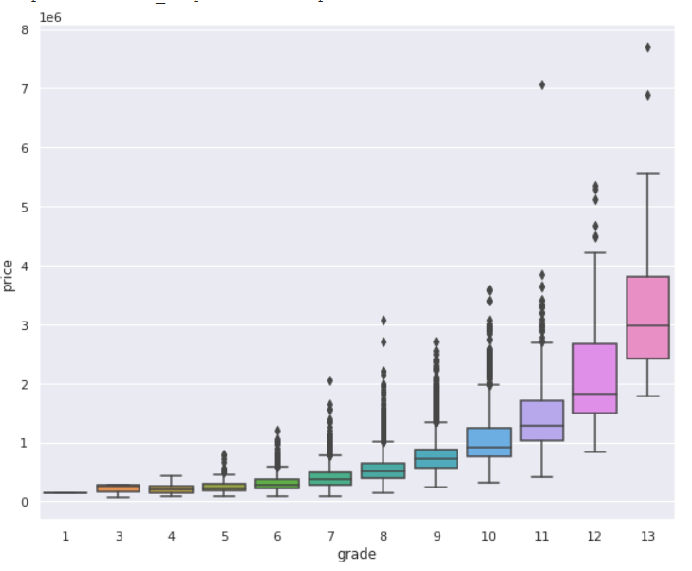
As the grade gets higher, the prices get higher exponentially. The overlaps between the boxplots increase more and more. This means that the differences between the prices of houses as the grades gets higher is more.

Fig 3: Bathrooms vs price boxplot
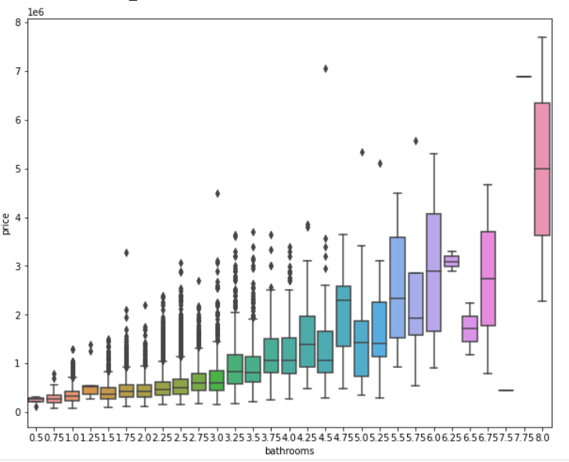
From this boxplot, we can see that generally, the prices will increase as the number of bathrooms increases. However, there are some values of bathrooms that are off of this trend, but mostly, the price of the house follows the trend of more bathrooms, higher price.

Data Preprocessing – Deskewing and removing outliers
After checking for relationships, I went to deskew and remove outliers from the non-categorical values such as sqft_lot, price, sqft_lot15, and age. I managed to make them more normal. Here is the process:
I checked for skewness in each variable (stated above)
Fig 4: sqft_lot before deskew
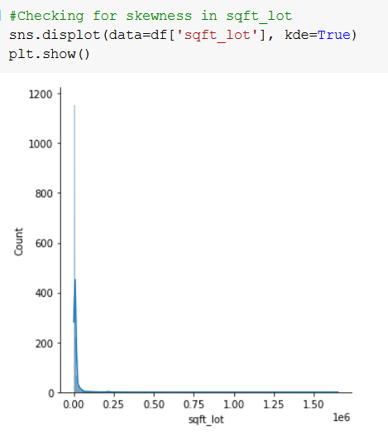

I deskewed eached variable
Fig 5: sqft_lot after deskew
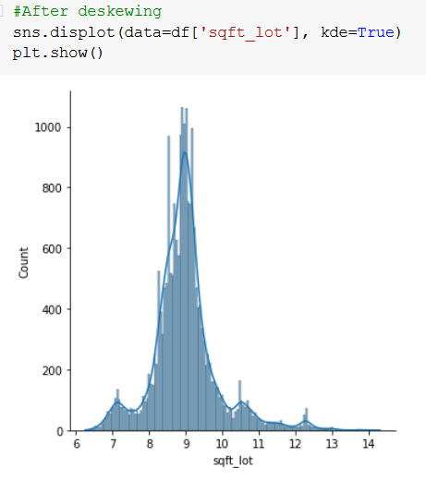
And I removed outliers from them
Fig 6: sqft_lot after removing outliers
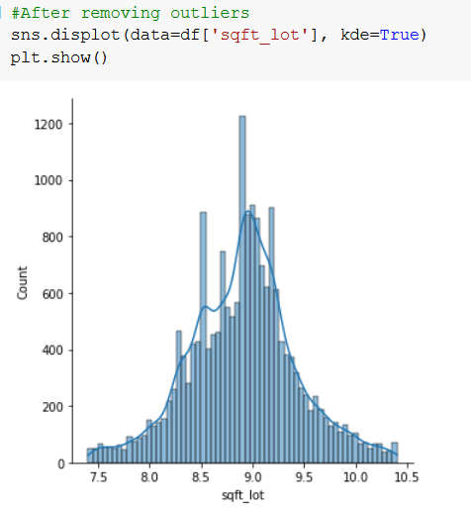
Until they all looked more normal.
Taking out the outliers caused NaNs to appear. I replaced the NaNs in categorical data with mode and the NaNs in non-categorical data with mean.
After that, I looked at the correlations of each variable with class. I produced this table to help visualize.
Fig 7: Correlation of variables vs Price
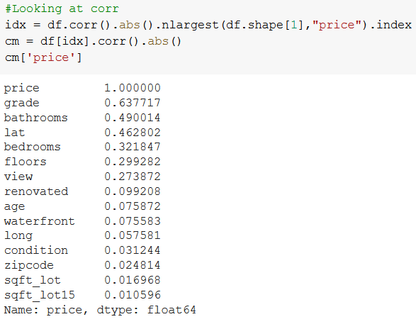
Having too many X variables can be detrimental to the model and cause it to overfit. This is known as the curse of dimensionality. Thus, I decided to remove some columns. More specifically, I decided to remove the last 5 columns. I split the data into X (features) and y (variable to be predicted), I split them into Train and Test sets. After that, I scaled them as the lat column looked very big in comparison to the others.
Fig 8: X.head(3)
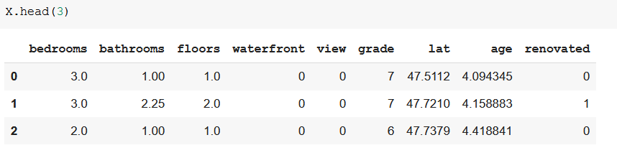
After scaling, I started to fit them into models.

Applying Models

The first model I decided to use was KNN. Before applying KNN, I applied GridSearchCV, with a cv of 10 to find the best parameters for KNN.
Fig 9: GridSearch for KNN
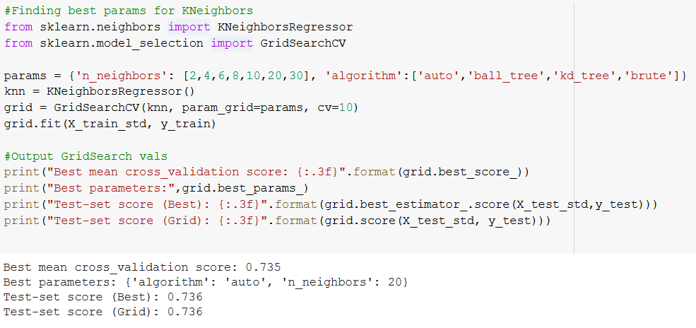
It gave me the parameters of algorithm = ‘auto’ and n_neighbors = 20. I used these parameters, and fitted my KNN model with my scaled data.
Fig 10: Fit variables in KNN
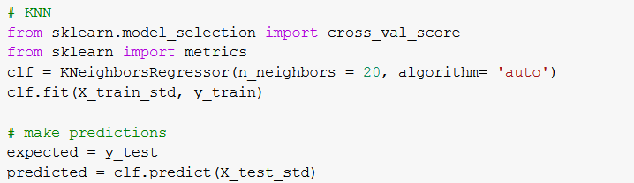

I summarized the MSE and R2 of both the train and test set, giving me this outcome:

Fig 11: MSE & R2 of KNN
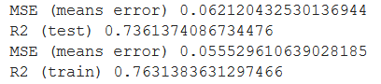

I then appended these MSE & R2 values into an array.
I then repeated these sets, finding the best params for other models I decided to use. The Models I decided to use include: A dummy model, Linear Regression, Lasso, Ridge, Decision Tree Regressor, Random Forest Regressor and Support Vector Regressor.

Deciding which model to use
After this, I compared the R2 test values of all the models I used.
Fig 12: Comparing R2(test) of all models
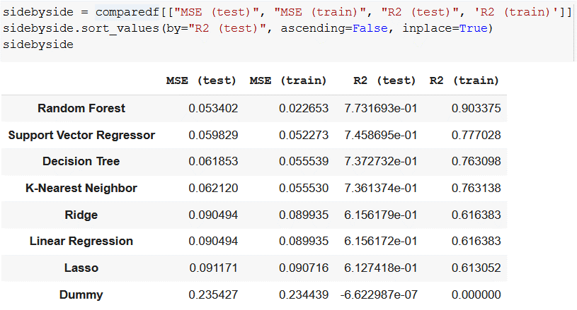

Out of all, the Random Forest Regressor has the highest test r2 score of 0.77317. This means that it has the highest correlation. It also has the least Mean Squared Error. Thus, I decided to pick Random Forest Regressor as my final model.

dDiscussion
Fig 13: Plot of Log(Actual Price) vs Log(Predicted Price)
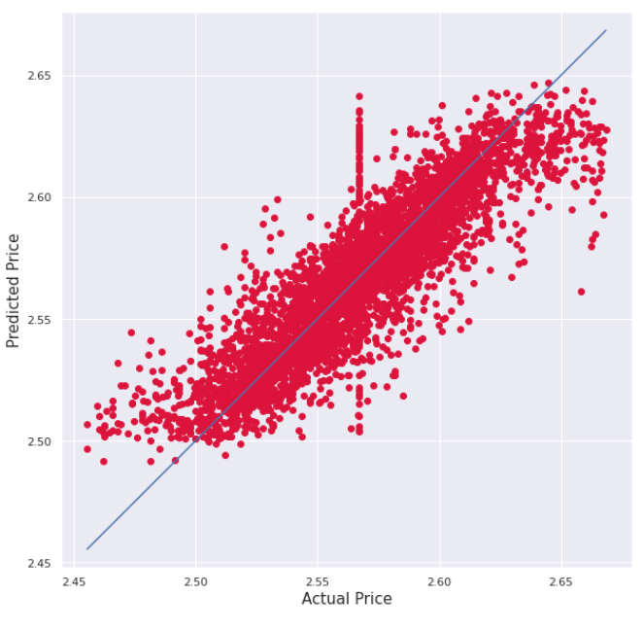
To evaluate the model, I plotted a scatter plot of my model’s Predicted Price and the Actual Price of the houses. I used the logarithm function to ensure that they are both in the

same scale. After that, I plotted a y=x line (in blue). If the values on the graph falls along this blue line, it means that the model is accurate in predicting values. For my model, it seems to generally fall on this blue line. However, there may have been some errors made, as there is a weird vertical line around the middle of the plot. Thus, it may not be so accurate.

Cconclusion

Fig 14: Features importance
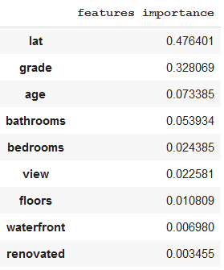
Latitude might be such a important feature to my model as house prices might be affected by its location. For instance, a house near the sea would probably be more expensive than a house located inland. Or a house in a more convenient area might be more expensive than a house in a more out of the way.

REFERENCES
- https://www.dataquest.io/blog/machine-learning-tutorial/, Predicting AirBnB prices
- Aishwarya Singh, Stock Prices Prediction Using Machine Learning and Deep Learning Techniques - https://www.analyticsvidhya.com/blog/2018/10/predicting-stock-price-machine-learningnd-deep-learning-techniques-python/

